**MongoDB Atlas**

**Colección – tareas**

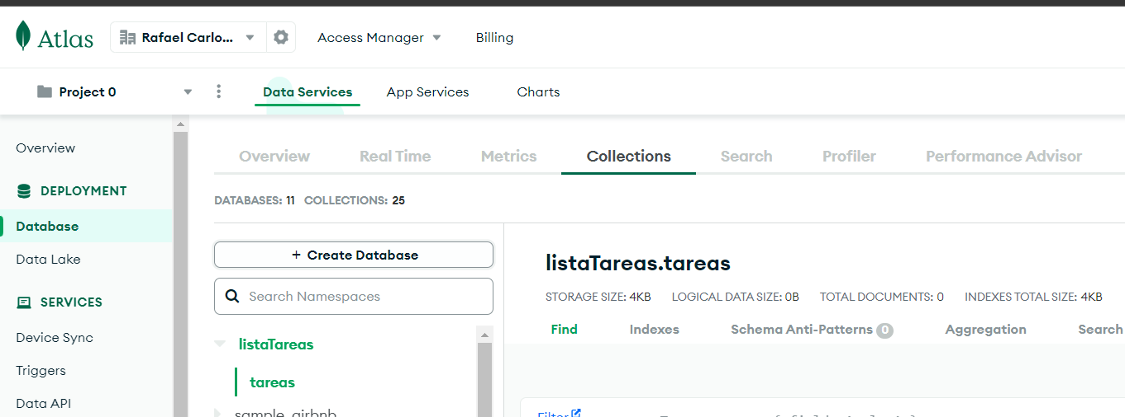

**Capturas de documentos**

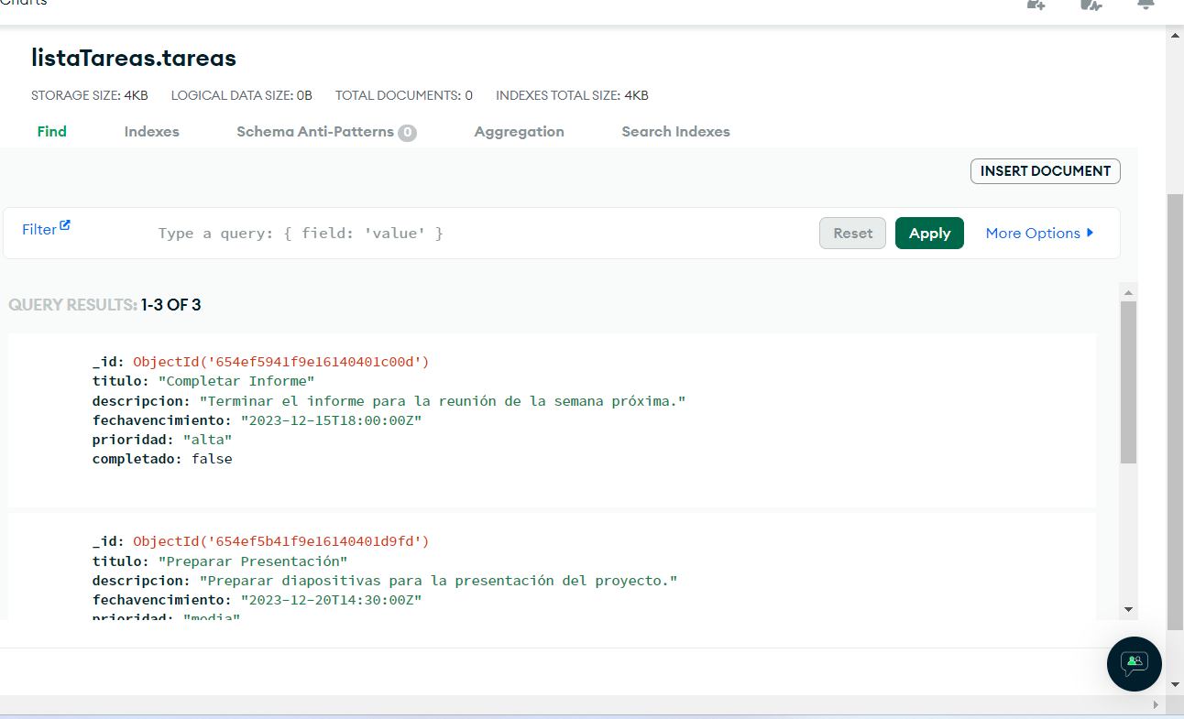

**Codigo para el crud con js**

const MongoClient = require('mongodb').MongoClient;

const uri = ‘mongodb+srv://rherrerasagastume:<password>@cluster0.t95pq3u.mongodb.net/?retryWrites=true&w=majority’;

const client = new MongoClient(uri, { useNewUrlParser: true, useUnifiedTopology: true});

async function readTareas() {

try {

await client.connect();

const database = client.db('listaTareas');

const collection = database.collection('Tareas');

const tareas = await collection.find({}).toArray();

console.log('Todas las tareas:', tareas);

} finally {

await client.close();

}

}

async function updateTarea(tareaId, updatedData) {

try {

await client.connect();

const database = client.db('listaTareas');

const collection = database.collection('Tareas');

await collection.updateOne({ _id: tareaId }, { $set: updatedData });

console.log('Tarea actualizada con éxito.');

} finally {

await client.close();

}

}

async function deleteTarea(tareaId) {

try {

await client.connect();

const database = client.db('listaTareas');

const collection = database.collection('Tareas');

await collection.deleteOne({ _id: tareaId });

console.log('Tarea eliminada con éxito.');

} finally {

await client.close();

}

}